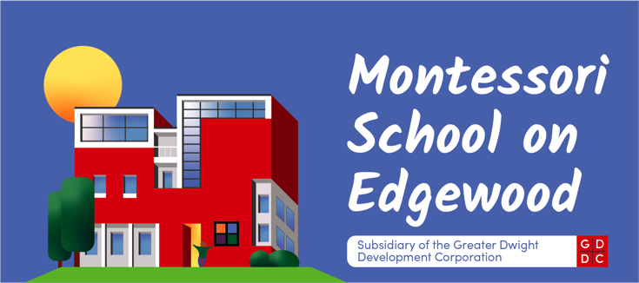

**Application for Admission**

**230 Edgewood Avenue**

**(203) 772-3210**

|  |  |
| --- | --- |
| **Student’s full name:** |  |
| Gender: | ( ) Male ( ) Female |
| Date of Birth: |  |
| Child’s Address: |  |
| Doctor/Phone Number: |  |
| Address: |  |
| Preferred Hospital: |  |
| Allergies/Health Information: |  |
| Medications: |  |

|  |
| --- |
| **How did you hear about our school? (referral or internet)** |

|  |  |
| --- | --- |
| **Primary Guardian** |  |
| Name: |  |
| Street: |  |
| Town; Zip Code: |  |
| Home Phone: |  |
| Cell Phone: |  |
| Work Address/Phone: |  |
| Office Phone: |  |
| Email Address: |  |
|  |  |
| **Secondary Guardian** |  |
| Name: |  |
| Street: |  |
| Town; Zip Code: |  |
| Home Phone: |  |
| Cell Phone: |  |
| Work Phone: |  |
| Office Phone: |  |
| Email Address: |  |

|  |  |  |  |
| --- | --- | --- | --- |
| **Name of Brother and Sisters** | **Date of Birth** | | **Present School** |
|  |  | |  |
|  |  | |  |
|  |  | |  |
|  |  | |  |
|  | | | |
| **Applying for:** | |  | |
| Start Date (include month and year) | |  | |
| Infant Toddler ( ) | |  | |
| Preschool ( ) | |  | |

|  |  |
| --- | --- |
| Previous School/ Childcare experience | Dates To From |
|  |  |
|  |  |
|  |  |

|  |  |  |
| --- | --- | --- |
| **Has your child had any specialized tests or evaluations?** | | |
| Test/ Evaluation | Administered by | Date |
|  |  |  |
|  |  |  |

|  |
| --- |
| What language(s) are spoken at home? |

|  |  |
| --- | --- |
| **Health** | |
| Describe your child’s general health? |  |
| Does your child have any physical limitations which would limit his/her participation in the full range of school activities? |  |
| Does your child have any known allergies? If yes, please explain…. |  |
| Has your child ever suffered any serious illness, injury, or hospitalization? |  |
| Is your child currently receiving and medication? |  |

|  |
| --- |
| **Application Procedure** |
| 1. Guardian(s) are invited to visit the school by appointment. |
| 1. Guardian(s) submit an application. |
| 1. All prospective students and guardians meet with a teacher or director. |
| 1. Upon acceptance a contract is offered. |

|  |  |
| --- | --- |
| Signature of Guardian(s) | Date |
|  |  |
|  |  |

|  |
| --- |
| Please mail the completed application along with a check for the **non-refundable** application fee of **$10.00** to: Montessori School on Edgewood- 230 Edgewood Ave- New Haven , CT 06511 |

**Parent Questionnaire**

We at the MSOE want to know how best to serve your child. This information will help us to become better acquainted with them. Please complete this form. We would like to thank you in advance for providing this useful information.

|  |
| --- |
| 1. By what name do you usually call your child? |
| 1. Who else lives in the home with your child? (Ex. aunt, siblings, etc.) |
| 1. What language is spoken at home (if other than English)? |
| 1. What is your cultural background? |
| 1. Has your child attended any other childcare programs before, if so, where and was the experience enjoyable? |
| 1. Is there any area in which you anticipate difficulty for your child? (Ex. Sharing, following directions, etc.) |
| 1. What seems to work best for you if your child is having a difficult time? ( for infants, what do you do to comfort your child when he/she is fussy? |
| 1. What are some activities that you do with your child? |
| 1. Is your child involved with activities outside of school? If so what? |
| 1. Does your child have any fears? Ex. Clowns, masks etc. |
| 1. What types of books does your child enjoy and does your child like to read as well? |
| 1. Are you able to read to your child as often? |
| 1. Were there any complications during your pregnancy? |
| 1. Was he/she born on time? Premature, if so how many weeks? |
| 1. At what age did your child crawl? Walk? Talk? |
| 1. Is your child potty trained? |
| 1. Do you have any developmental concerns about your child/referrals to agencies? |
| 1. What other information would you like us to know about your child? |
| 1. Are there any nutritional needs that must be net with your child? |
| 1. Would you like to volunteer at MSOE? |
| 1. Any resources that **YOU** need help with? **CIRCLE ONE**- Insurance, Family Literacy, Job Training, Adult education, College, Parenting, Housing, Mental Health, GED **if yes please see an administrator for a referral form.** |
| 1. What is the name of your Health Insurance Company? |

Child’s Name______________________________________________________

Parent/Guardian Signature____________________________________________